SIMPLE EXAMPLE APPLICATIONS FOR UNDERSTANDING OF FBRT BLOCKS

Now that we are familiar with the fbrt blocks we shall see some example applications and practically use the blocks. You need to have knowledge of the publisher and subscriber blocks . You can see the default app X+3 in 4DIAC-IDE for that.
Generally we will take input from the FBRT window and publish it to another resource. The resource will subscribe the data and it will be processed and will again be published to the FBRT.The output will be subscribed by the FBRT resource. In the FBRT window the output will be visualised.

1. PROBLEM STATEMENT: To build an application which will visualise the speed control of a vehicle. There will be two controls 1. acceleration control, 2. brakes control. When the speed increases more than 70kmph, Acceleration shall be stopped and when the speed increases more than 90kmph, the brakes shall be applied. Speed input should be given by the user and output must be visible .

SOLUTION:
FUNCTION BLOCKS TO BE USED:
- E_CYCLE
- FB_SLIDER
- F_GE
- F_GT
- OUT_BOOL
- FB_BAR
- PUBLISH
- SUBSCRIBE

STEPS TO BUILD THE APPLICATION:
- E_CYCLE triggers the FB_SLIDER every 250 ms.
- OUT of FB_SLIDER is given to the IN1 of the F_GT and F_GE blocks.
- IN2 of the F_GT and F_GE blocks are given 70 and 90 values respectively.
- OUT of the F_GE and F_GT blocks are given to the IN of OUT_ BOOL1 And OUT_BOOL2 respectively.
- IN of FB_BAR is given by OUT of FB_SLIDER.
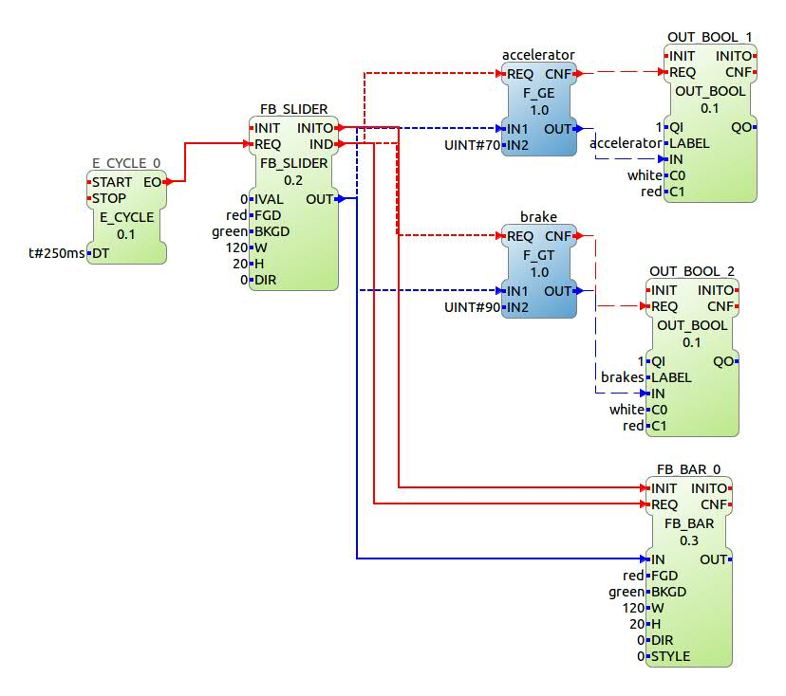
- By this application, the user can move the slider and can give a speed input . This speed is then compared in the F_GE and F_GT blocks and boolean output is given to the FBRT block which will be shown on the screen.

STEPS FOR BUILDING SYSTEM CONFIGURATION:
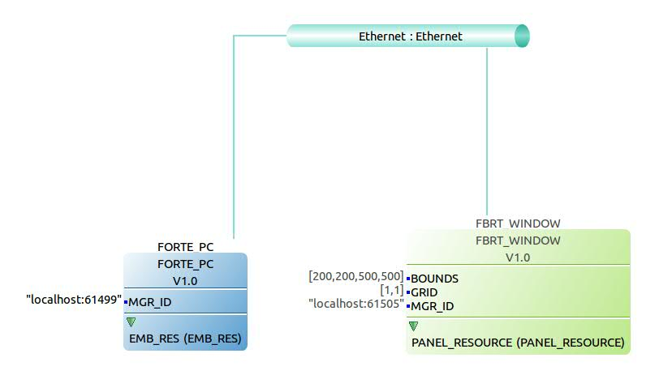
We use two resources in this application:
1.FORTE PC
2.FBRT WINDOW
connected through an ethernet.
- All the FBRT blocks and the E_CYCLE block are mapped to the FBRT PANEL_RESOURCE
- The F_GT and F_GE blocks are mapped to the FORTE PC EMB_RES

FBRT_WINDOW PANEL_RESORCE:
- The OUT of the FB_SLIDER is given to SD1 of PUBLISH. PUBLISH is initiated by INITO of FB_SLIDER. REQ is triggered from IND of FB_SLIDER. A unique ID is given to it. This Publishes the data to the FORTE_PC.
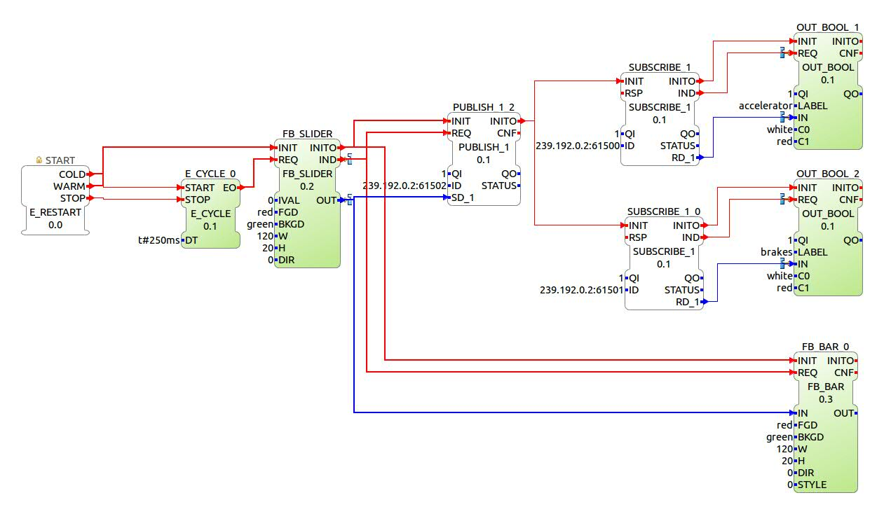
- There are two SUBSRIBE blocks with a unique ID that would subscribe the data published in FORTE PC. They are initiated from INITO of the PUBLISH block.RD_1 of these blocks give data to IN of OUT_BOOL1 and OUT_BOOL2.INIT and REQ of OUTBOOL blocks are triggered from SUBSCRIBE blocks.
- FORTE_PC EMB_RES:
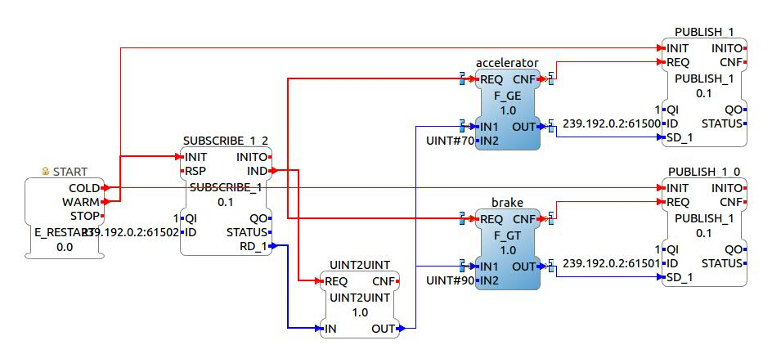
- The data that was published in the FBRT WINDOW will noe be subscribed using SUBSCRIBE with the same ID given to its PUBLISH block.
- Data recieved RD_1 will be coverted into UINT using UINT2UINT block.
- This OUT will be given to both IN1 of accelerator and brake.
- Their OUT is then Published using PUBLISH with the ID same as that of their SUBSCRIBE counterparts in the FBRT WINDOW. They are initiated from E_RESTART and triggered from CNF of F_GE And F_GT blocks.
This application can now be deployed to the resources one by one and tested. This application has been enclosed under the name SpeedControl_example in the folder. You can import it to your workspace.
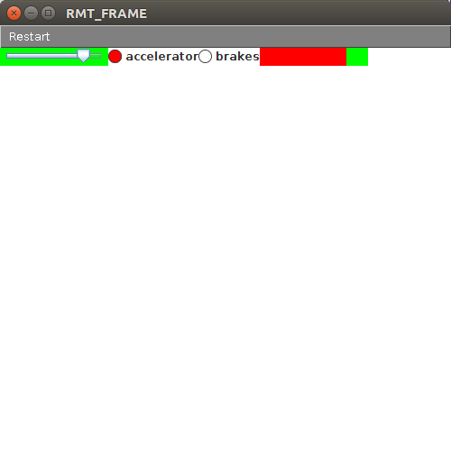
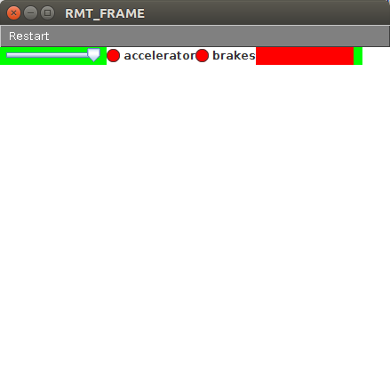

2. PROBLEM STATEMENT: Build an application such that the user gets four switches – FRONT, BACK, LEFT, RIGHT. According to the switch pressed, the two motors (left and right), move either front or back. This has to be shown on the fbrt window.

SOLUTION: The fundamental of this application is the direction of both the motors when each button is pressed.
- FRONT - left motor - front, right motor - front
- BACK - left motor - back, right motor - back
- LEFT - left motor - back, right motor - front
- RIGHT - left motor - front, right motor – back

FUNCTION BLOCKS USED TO BUILD THE APPLICATION:
- IN_EVENT
- E_SR
- OUT_BOOL
STEPS TO BUILD THE APPLICATION:
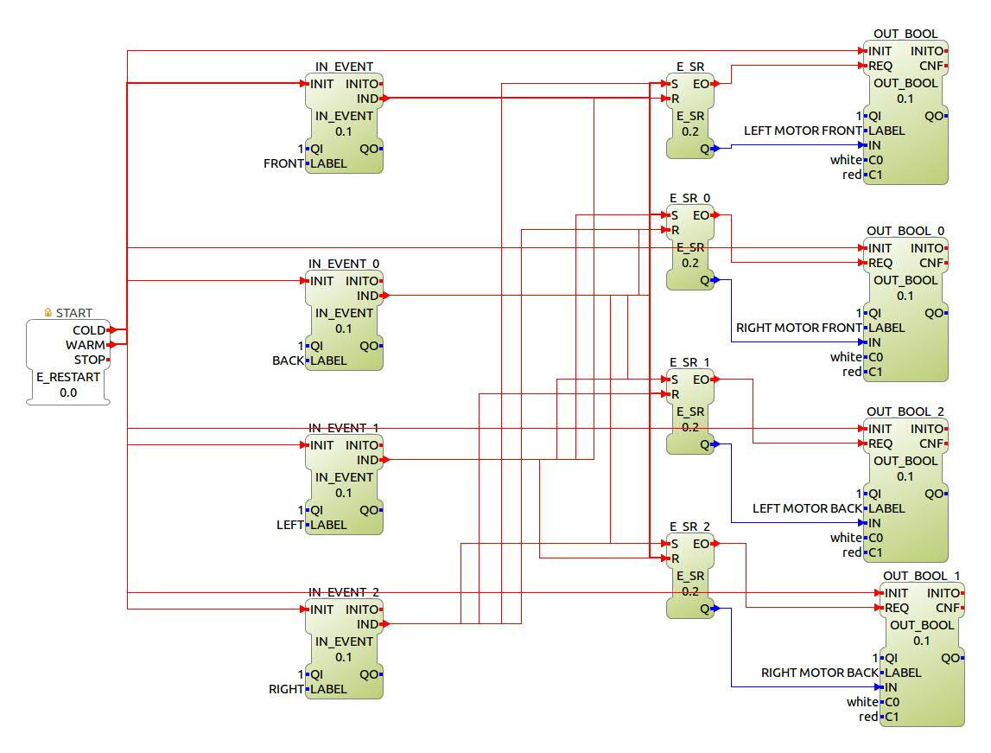
- There are four IN_EVENT blocks, each corresponding to one button with label, FRONT, BACK, LEFT, RIGHT resppectively.
- IND of each IN_EVENT triggers each of the SR blocks depending on the requirement.
SL.NO | IN_EVENT LABEL | E_SR | E_SR_0 | E_SR_1 | E_SR_2
1 | FRONT | S | S | R | R
2 | BACK | R | R | S | S
3 | LEFT | R | S | S | R
4 | RIGHT | S | R | R | S

- EO of each SR block triggers the REQ of its corresponding OUT_BOOL block. And Q of each SR block is given to the IN of respective OUT_BOOL block.
The entire application is mapped to the FBRT PANEL RESOURCE and deployed.
This application has been enclosed in the folder under the name MotorControlFBRT.

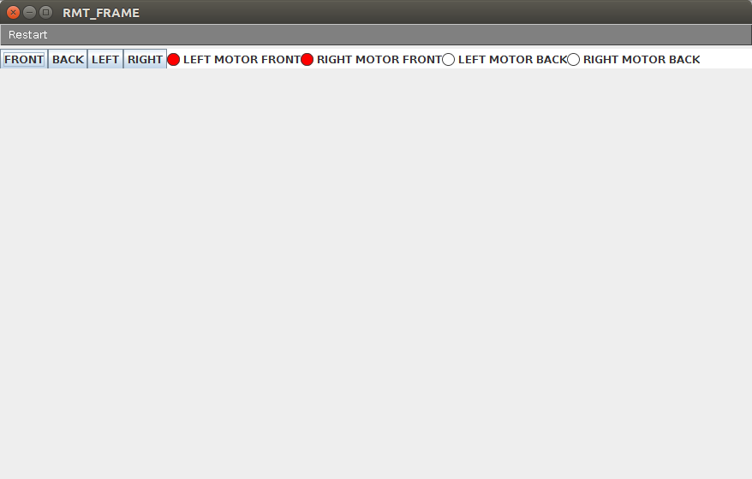

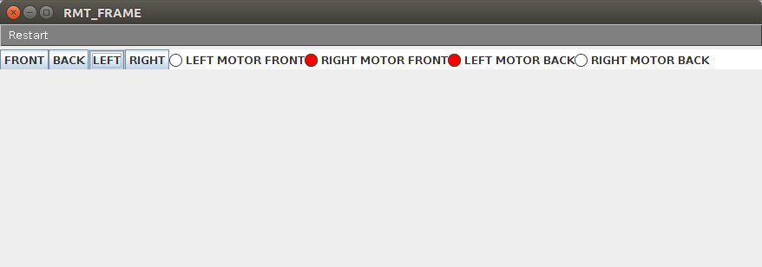
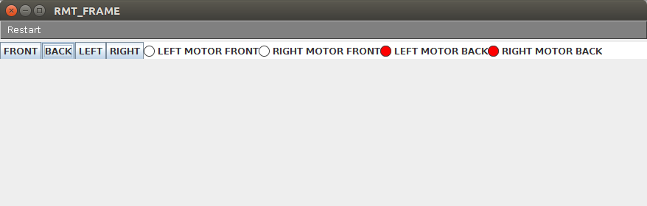

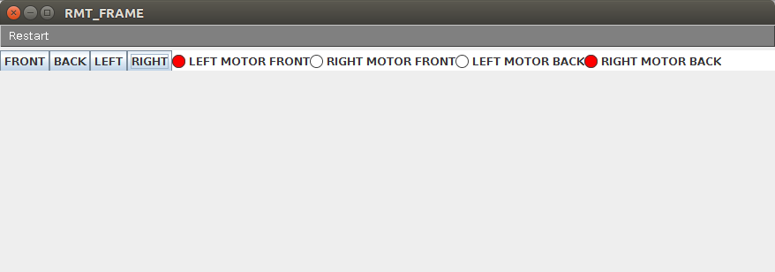

3. PROBLEM STATEMENT: To build a 2 storeyed elavator system with four inputs named IN UP, IN DOWN, OUT UP, OUT DOWN, and 4 FBRT output showing the direction of movement of the lift and floor at which the lift currently is.For demonstration purpose assume it takes 5seconds for the elavator to move from one floor to another floor.

SOLUTION: In practical cases in an elavator system there are limit switches that get switched on when a lift fully reaches a particular floor. But here for demonstrating a lift using FBRT blocks we will assume that it takes 5seconds to reach a floor. So the limit switches must be switched on automatically after 5s after the lift starts moving.
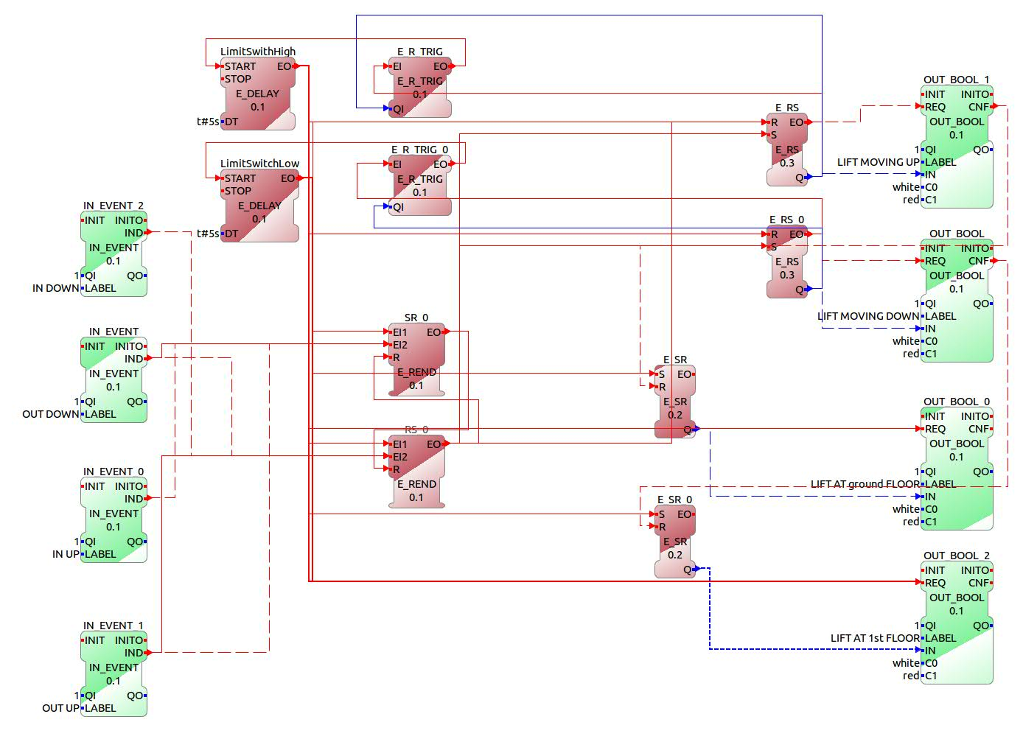

Cases for the elavator to move UP when lift is at ground floor:
- OUT UP is pressed: someone on the ground floor outside wants to go up.
- OUT DOWN is pressed: someone on the 1st floor needs to go down.
- IN UP is pressed: someone inside the lift needs to go up.
So we need to use a E_REND block with one input coming from LimitSwitchLow and the other other input coming from the above three events.

Cases for the elavator to move DOWN when lift is at 1st floor:
- IN DOWN is pressed: someone inside the lift wants to go down.
- OUT DOWN is pressed: someone on the 1st floor outside wants to go down.
- OUT UP is pressed: someone on the ground floor outside wants to go up.
So we need to use a E_REND block with one input coming from LimitSwitchHigh and the other other input coming from the above three events.

Therefore we have four IN_EVENTS blocks with the lables IN UP, IN DOWN, OUT UP, OUT DOWN respectively. Their IND are connected to two E_REND blocks as per the reqirement.The upper block is for moving the lift UP and the lower block is for moving it down.
Now we have 2 E_SR blocks that would give boolean output to the fbrt blocks. The upper block gives its output to OUT_BOOL with label LiftMovingUP.
The lower block its output to OUT_BOOL with label LiftMovingDown . The EO of the upper REND block must trigger the S of the upper SR block and R of the lower SR block. The EO of the lower REND block must trigger the R of the upper SR block and S of the lower SR block. In this way Q of the upper SR blocks become TRUE only when it has to move UP.In this way Q of the lower SR blocks become TRUE only when it has to move DOWN.
Now that the lift can move either up or down, we must specify the time after which reach their destination. So we use two E_DELAYs with DT 5s. These will be triggered from two E_R_TRIG blocks. These two are triggered from the two E_SR blocks respectively. Q to E_R_TRIG blocks come from the Q of the E_SR blocks respectively. As we know the E_TRIG generates events only when Q changes from 0 to 1, i.e when lift starts moving UP or DOWN(as discussed earlier). Therefore now when lift starts moving UP (or DOWN), E_DELAY will be triggered and it will generate an event after 5s. These two E_DELAYs become our limit switches. Upper one is the LimitSwitchHigh and the lower one is the LimitSwitchLow.

Now for showing the floor at which the lift is present, we require two more E_SR blocks. When LSL is ON the lift is on the ground floor and when the LSH is on the lift is on the 1st floor. So the output event of the LSL and LSH must trigger the S of the two SR blocks. And the R must be triggered by the two OUT_BOOL blocks with labels LIFT MOVING UP and LIFT MOVING DOWN respectively. This will ensure that the SR blocks output is true only when their Limit switches are ON.

Further, the lift must STOP once it reaches a floor, for that we give the Limit switch output events to both the R of the E_SR blocks.(E_SR block mentioned here are the blocks that we made initially for determining the movement of the lift and not the ones that we created lately for position of the lift.)

We will deploy this application on two resources namely FBRT WINDOW PANEL RESOURCE and the FORTE PC EMB RES. We will use the publisher and subscriber blocks for communication between the resources.

FORTE PC EMBEDDED RESOURCE:

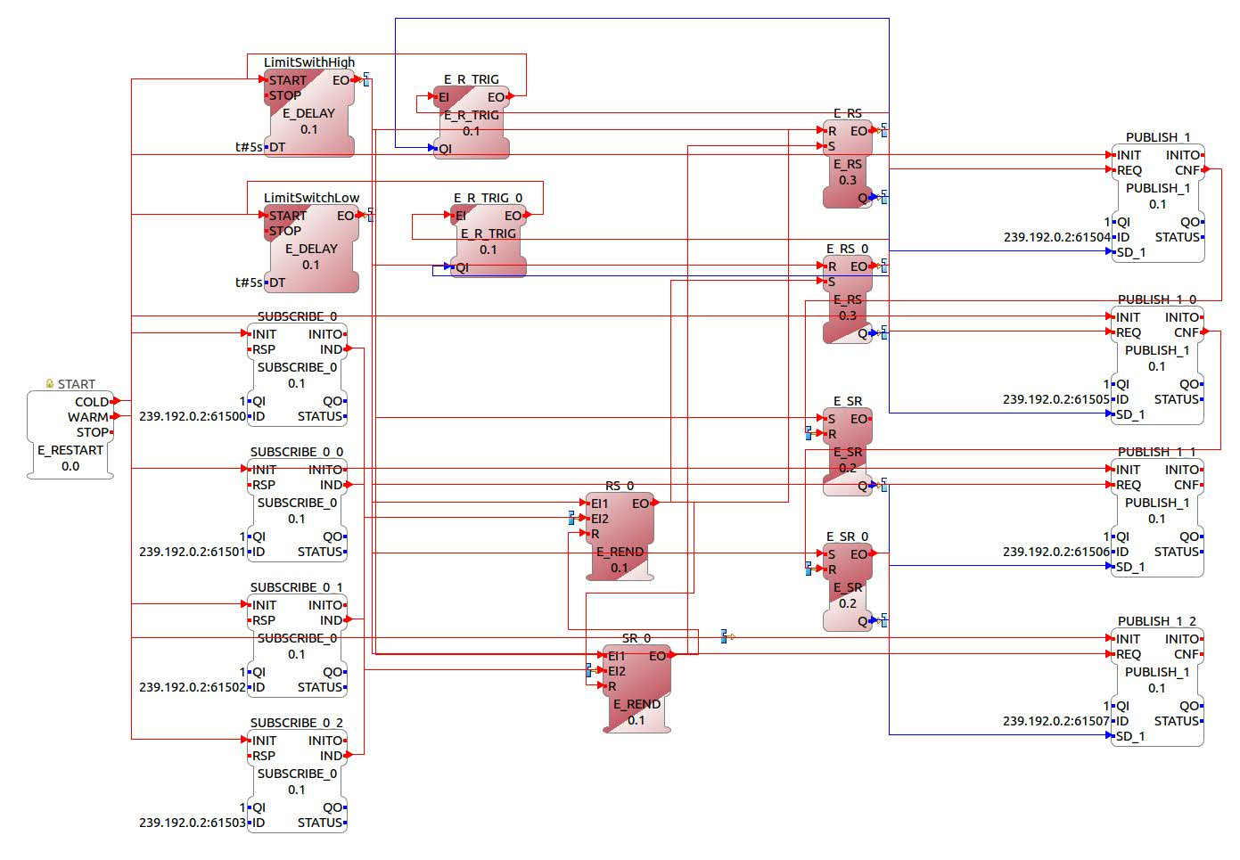
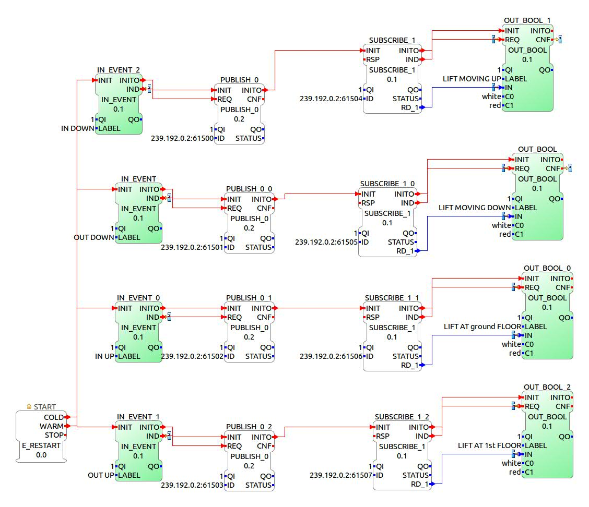
FBRT PANEL RESOURCE:

This application has been enclosed in the folder with name Elavator_Example. You can import it to your workspace and use it.

